

**Exploratory Analysis of the PIZZA PALACE**

Report by: Farrukh Nizam Arain  
Designation: Data Analyst  
Date: 28th February 2023

**Introduction:**

Pizza Palace is a fictious regional pizza maker located in the suburbs of a metropolitan area. Pizza Palace strives to deliver healthy, speciality pizzas and side dishes. They offer a wide spectrum of competitive pricing. Pizza Palace targets customers like commuters and workers who lack the time or ability to prepare a family dinner.  
  
**Problem Statement:**  
The purpose of my assessment in this project is to answer the questions below by analyzing the different aspects of sales in the fictious Pizza Palace. The important questions were:

1. How many customers do we have each day? Are there any peak hours?
2. How many pizzas are typically in an order? Do we have any bestsellers?
3. How much money did we make this year? Can we identify any seasonality in the sales?
4. Are there any pizzas we should take of the menu, or any promotions we could leverage?

**Preparation of the Datasets:**

Public datasets were downloaded at the following [link](https://www.mavenanalytics.io/data-playground) provided by Maven Analytics under this [license](https://www.mavenanalytics.io/terms-for-individuals). No issues with bias and credibility were found with the data through the methodology of ROCCC.

Following are the list of files (in CSV format) and the descriptions:

|  |  |
| --- | --- |
| Filename | Description |
| Order_details.csv | Details of the Pizza order of a year |
| orders.csv | Dates and times of the orders received |
| pizza_types.csv | Types of the Pizzas baked in the restaurant |
| pizzas.csv | Pricing & size details of all the pizzas |

After inspecting the datasets provided by the DB administrators hired by the company, it was seen that they are normalized, and I proceeded to processing the data.

Processing of the Datasets:

The tools that I used for data processing are:

* Microsoft Excel 365
* SQL Server 2022
* SSMS 19

To remove any ambiguity of the fields used in the database, I created a data dictionary to make it easier for the reader to better understand it .

|  |  |  |
| --- | --- | --- |
| Table | Field | Description |
| orders | order_id | Unique identifier for each order placed by a table |
| orders | date | Date the order was placed (entered the system prior to cooking & serving) |
| orders | time | Time the order was placed (entered the system prior to cooking & serving) |
| order_details | order_details_id | Unique identifier for each pizza placed within each order (pizzas of the same  type and size are kept in the same row, and the quantity increases) |
| order_details | order_id | Foreign key that ties the details in each order to the order itself |
| order_details | pizza_id | Foreign key that ties the pizza ordered to its details, like size and price |
| order_details | quantity | Quantity ordered for each pizza of the same type and size |
| pizzas | pizza_id | Unique identifier for each pizza (constituted by its type and size) |
| pizzas | pizza_type_id | Foreign key that ties each pizza to its broader pizza type |
| pizzas | size | Size of the pizza (Small, Medium, Large, X Large, or XX Large) |
| pizzas | price | Price of the pizza in USD |
| pizza_types | pizza_type_id | Unique identifier for each pizza type |
| pizza_types | name | Name of the pizza as shown in the menu |
| pizza_types | category | Category that the pizza falls under in the menu (Classic, Chicken, Supreme,  or Veggie) |
| pizza_types | ingredients | Comma-delimited ingredients used in the pizza as shown in the menu (they all include Mozzarella Cheese, even if not specified; and they all include  Tomato Sauce, unless another sauce is specified) |

I created database named ‘pizzapalaceanalysis’, created relevant tables, formed relationships, and created database diagram in between them.

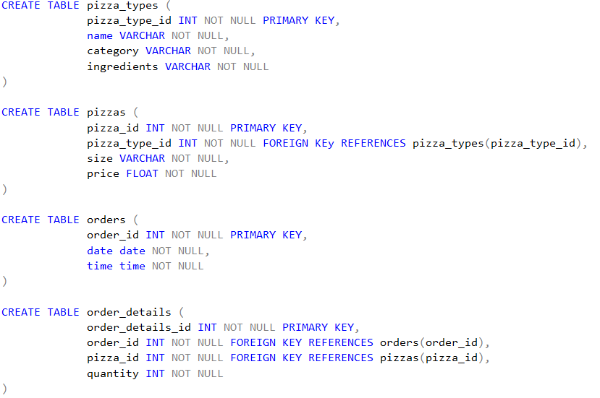

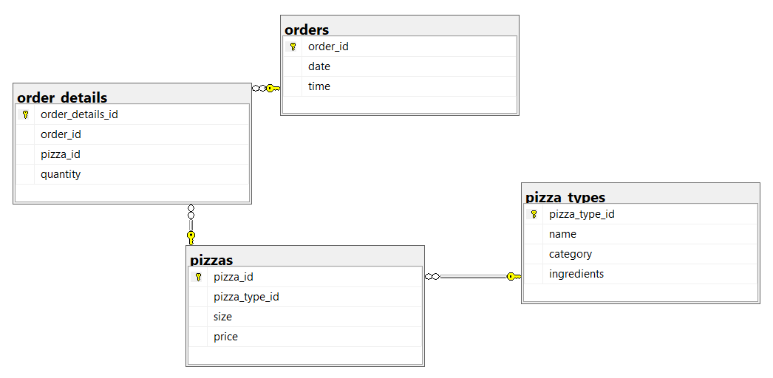

After laying out the structure of the table, I appended data via SQL Server’s Import and Export Wizard from CSV format.

**Analysis of the Datasets:**

I discussed what the clients wanted from their data and what questions they want to be answered to help expand / model their existing business model for the better.

1. **How many customers do we have each day? Are there any peak hours?**If we count the number of orders each day throughout the years, we can conclude that Thursdays, Fridays, and Saturdays were the days when most orders were recorded. Surprisingly, Sunday was the day when least number of customers approached our restaurants.  
     
   I queried the orders table and included the relevant columns for analysis.  
     
     
     
   The Tabular analysis and Visualization further confirmed my analysis. The marketing department needs to launch promotional activities to lure the customers to visit the food chain on Sundays to contribute to the overall profitability of the company.

|  |  |
| --- | --- |
| **Weekdays** | **Number of Orders** |
| Friday | 3538 |
| Thursday | 3239 |
| Saturday | 3158 |
| Wednesday | 3024 |
| Tuesday | 2973 |
| Monday | 2794 |
| Sunday | 2624 |

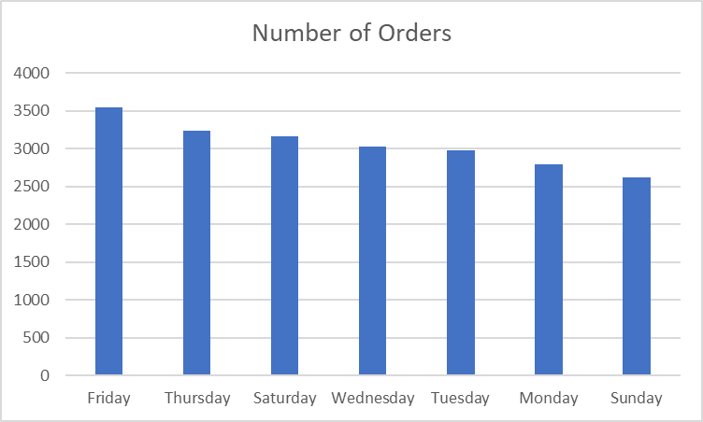

Regarding peak hours, I made use of the same orders table is extracting the time of the orders, compiled them by hours and then grouped / ordered them accordingly.

  
  
Although it was encouraging to observe that pizzas were popular by the customers during their lunch time (12:00 – 13:00), the demand dipped to the lowest levels during the dinner time. It is an alarming situation because people visit these places more often than the lunch hours. Additionally, location of some of the restaurants somewhat contributed to the sales during suppertime, else the sales wouldn’t have been touching near those during lunch times.

|  |  |
| --- | --- |
| **Hours** | **Number of Orders** |
| 12:00 | 2520 |
| 13:00 | 2455 |
| 18:00 | 2399 |
| 17:00 | 2336 |
| 19:00 | 2009 |
| 16:00 | 1920 |
| 20:00 | 1642 |
| 14:00 | 1472 |
| 15:00 | 1468 |
| 11:00 | 1231 |
| 21:00 | 1198 |
| 22:00 | 663 |
| 23:00 | 28 |
| 10:00 | 8 |
| 09:00 | 1 |

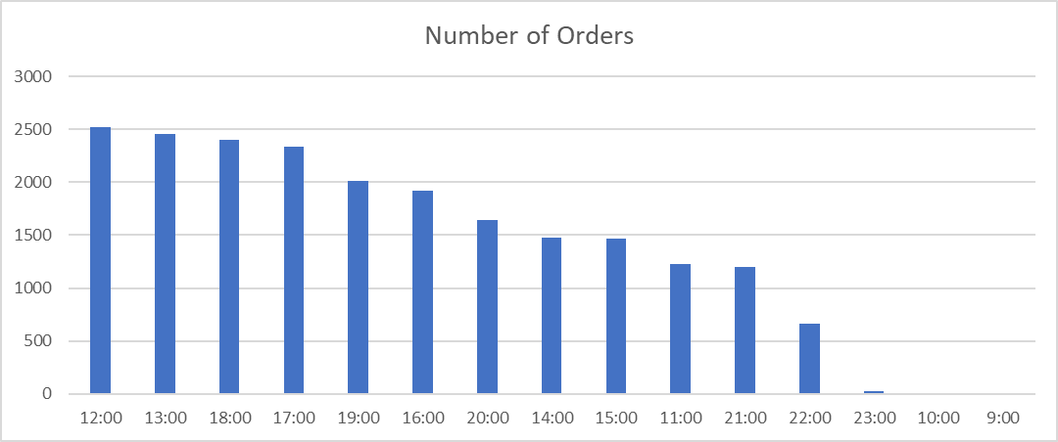

1. **How many pizzas are typically in an order? Do we have any bestsellers?**To calculate average number of pizzas per order, I created a temporary table and named it number_of_order. The reason for the creation was to extract the quantities of pizzas and calculate the average of the quantities.   
     
   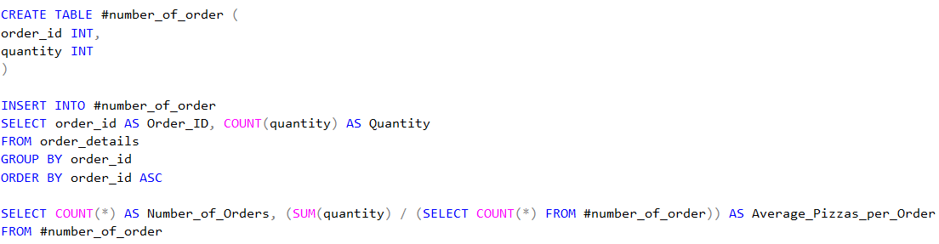  
     
   According to the extracted data, it was found out that 2 pizzas were on an average ordered in each order.

|  |  |
| --- | --- |
| **Number of Orders** | **Average Number of Pizzas / Order** |
| 21350 | 2 |

To calculate the top sellers, I added up the different pizza types ordered and grouped them accordingly.   
  
  
  
Due to the popularity of BBQ Chicken flavored pizza, both large and medium sized pizzas have collectively sold **1948** items last year, with Big Meat (Small) and Thai Chicken (Large) Pizzas coming close at second and third places, respectively.

|  |  |
| --- | --- |
| **Pizza Flavors** | **Quantities Ordered** |
| big_meat_s | 1914 |
| thai_ckn_l | 1410 |
| five_cheese_l | 1409 |
| four_cheese_l | 1316 |
| classic_dlx_m | 1181 |
| spicy_ital_l | 1109 |
| awaiian_s | 1020 |
| southw_ckn_l | 1016 |
| bbq_ckn_l | 992 |
| bbq_ckn_m | 956 |

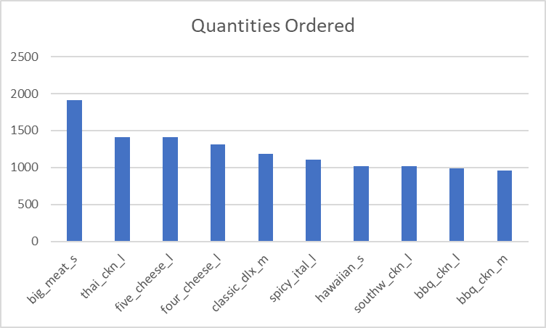

1. **How much money did we make this year? Can we identify any seasonality in the sales?**  
   For calculating up the sales for the year, I added up the quantities and the sales amount of all the items within order_details table.  
     
   

|  |  |
| --- | --- |
| **Items Sold** | **Sales for the Year** |
| 49574 | $817860.0508 |

Regarding finding out any patterns in seasonality in sales per month, I bifurcated the sales in all the months of the year. After analyzing and modeling data, I was observed that during the first three quarters of the year, sales hovered around $77,000 to $66,000. However, during September, October, the sales dipped to the lowest sales at just above $64,000. Interestingly, November saw a significant increase to just above $70,000, but it dipped again to around $65,000 during December.

|  |  |
| --- | --- |
| **Months** | **Sales Amount** |
| January | 69793.30007 |
| February | 65159.60007 |
| March | 70397.10007 |
| April | 68736.80008 |
| May | 71402.75007 |
| June | 68230.20007 |
| July | 72557.90007 |
| August | 68278.25006 |
| September | 64180.05006 |
| October | 64027.60008 |
| November | 70395.35007 |
| December | 64701.15008 |

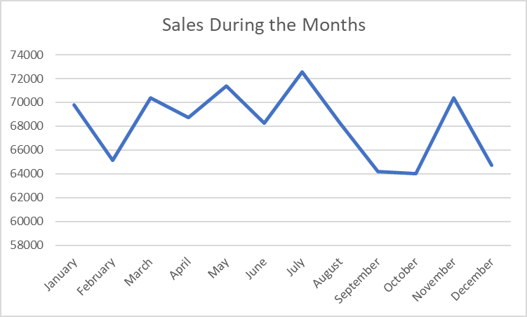

1. **Are there any pizzas we should take off the menu, or any promotions we could use?**  
   The last query was a bit tricky because I had to go through the sales of each pizza type throughout the last year via executing this query.  
     
   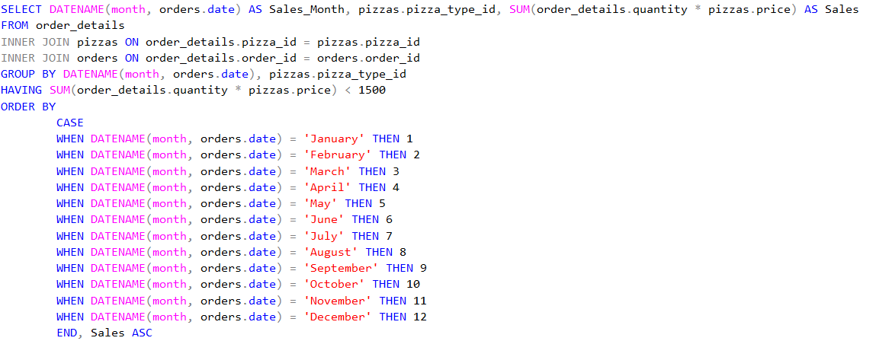

After consulting with the respective stakeholders, they wanted to know the flavors which had sales around $1000 and asked which flavors should be taken off the menu and which can have promotions to increase the sales.   
  
So, I found out that 2 flavors of pizzas had the least number of sales throughout the year. Brie Carre flavor had the average of just $965 of sales each month, so it should be taken off the menu because it is heavily contributing to the operational costs. Moreover, Green Garden flavor had the average of $1162 per month, so the marketing team can launch a promotional campaign if they want to continue with the sale of his product.  
  


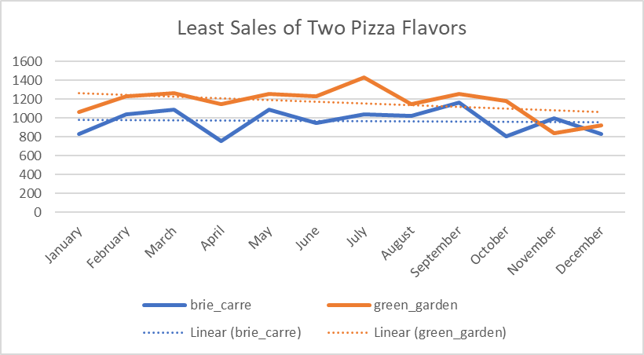

**Conclusion of the Analysis:**During this project, I analyzed the sales results of a fictious Pizza Palace company to not only extract and analyze the trends and patterns, but also suggested actions based on data for better profitability for the company.